**TEST PLAN**

**(WARDROBE PROJECTION)**

*ChangeLog*

|  |  |  |  |
| --- | --- | --- | --- |
| **Version** | **Change Date** | **By** | **Description** |
| version number | Date of Change | Name of person who made changes | Description of the changes made |
| 001 | 20-10-23 | PRACHI VERMA, PRAGATI TOMAR |  |

**Prof. Anurag Tewari Prof. Abhishek Goyal**

**(Project Guide) (Testing Lab Faculty)**

**Submitted by:** **Submitted To:**

**Prachi Verma (2000290120109) – 7B**  **Prof. Neha Shukla**

**Pragati Tomar (2000290120110) – 7B** **Project Coordinator**

1 INTRODUCTION 2

SCOPE 2

In Scope 2

Out of Scope 3

QUALITY OBJECTIVE 3

ROLES AND RESPONSIBILITIES 3

1. TEST METHODOLOGY 3

OVERVIEW 3

TEST LEVEL 3

TEST COMPLETENESS 5

1. TEST DELIVERABLES 5
2. RESOURCE & ENVIRONMENT NEEDS 5

TESTING TOOLS 8

TEST ENVIRONMENT 9

1. TERMS/ACRONYMS 9

# Introduction

One of the most popular items sold online, where online shopping has been increasingly popular in recent years, is clothing. However, one drawback of internet buying is that buyers cannot try on clothing to see if it fits them before making a purchase. As a result, consumers find that virtually trying on clothing is really convenient.

The fashion sector now has fantastic potential because of the quick development of computer vision, machine learning, and artificial intelligence. Two of the most under-researched applications of artificial intelligence (AI) in the realm of fashion design are fashion try-on and synthesis.

Artificial intelligence and machine learning are assisting in easing the transition away from traditional retailers.

In order to enable virtual try-on without restricting the view direction of people or the target clothing, we wish to design a system that leverages photographs.

This makes it easier for customers to try on clothing, which encourages buying interest and keeps costs down for clothing retailers.

This project aims to make it possible for users to virtually try on clothing. When users upload both their own and the clothes’ photograph, we will be able to create a shot of the subject wearing the clothing. Other virtual try-on techniques emphasize the person's and the clothing's front views. Our approach, however, will be capable of handling front and slightly turned-view orientations.

Additionally, users may have the option of camera when he/she wants to try on a cloth so that the uploading time of photo is saved.

Apart from all this, we may add some recommendation system of clothes for the user.

## Scope

### In Scope

**Functional Requirement:-**

Image Input: The system must accept input images in various formats (e.g., JPEG, PNG) for both content and style images.

Virtual Try-on Model: The system shall work with Virtual try-on model to combine the content of two image, one of human and the other of cloth which should be warped on the human image as the output.

User Interface: The system should provide a user-friendly interface for users to upload content and see the wardrobe projection of cloth.

Output Options: Users should have options to save, download, or view the generated images.

#### Non-Functional requirement:-

Performance:

Speed: The system should perform wardrobe projection efficiently, with minimal processing time. Scalability: It should be able to handle a scalable number of concurrent requests.

### Out of Scope

Out of scope for the wardrobe-projection project are complicated side angles, highly specialized hardware, real- time video processing, and in-depth image editing features, among others.

## Quality Objective

* Ensure the Application Under Test conforms to functional and non-functional requirements
* Ensure the AUT meets the quality specifications defined by the client
* Bugs/issues are identified and fixed before go live
* Ensure that the style transfer process is optimized for efficiency and speed, allowing for rapid transformation of images while maintaining high-quality results.
* Prioritize a user-friendly and intuitive interface to enhance user experience, making it easy for users to upload images and customize style transfer.
* Ensure that the system functions correctly on a variety of devices, browsers, and operating systems to maximize user accessibility.

## Roles and Responsibilities

Detail description of the Roles and responsibilities of different team members like

* **QA Analyst**- Prachi Verma
* **Test Manager**- Mr. Abhishek Goyal
* **Configuration Manager**- Prof. Akankskha
* **Developers**- Pragati Tomar, Prachi Verma

# Test Methodology

## Overview

An Agile methodology is the most suitable for my project. It allows for flexibility, ongoing testing, and adaptation, which are essential for projects that involve machine learning, image processing, and AI. Agile enables you to respond to changing requirements and refine the wardrobe projection model algorithm as you gain insights from testing and user feedback.

## Test Levels

**Test Levels define the Types of Testing to be executed on the Application Under Test (AUT**). The Testing Levels primarily depends on the scope of the project, time and budget constraints.

#### Unit Testing:

Scope: Individual components and functions of the neural style transfer algorithm.

Objective: To verify that each component works as intended, including layers, loss functions, and optimization steps.

Testing Approach: Developers and machine learning engineers conduct unit tests to validate the correctness of the algorithm at a granular level.

#### Integration Testing:

Scope: The interactions and interfaces between various components, libraries, and frameworks used in the project.

Objective: To ensure that the integration of different components does not introduce errors or inconsistencies in the style transfer process.

Testing Approach: Developers and testers assess the data flow and interactions between components and detect any integration issues.

#### Functional Testing:

Scope: The complete wardrobe projection system.

Objective: To validate that the system functions according to specified requirements and that it performs accurate virtual try-on.

Testing Approach: Testers execute functional tests by providing input images and verifying that the output images meet the desired content and virtual-projection criteria.

#### Performance Testing:

Scope: Assessing the system's speed and efficiency in handling style transfer tasks.

Objective: To measure how well the system performs in terms of processing time, memory utilization, and resource consumption.

Testing Approach: Performance tests evaluate the system's response time and resource usage under various loads and conditions.

#### Usability Testing:

Scope: The user interface and user experience.

Objective: To assess how user-friendly and intuitive the interface is for users uploading content i.e human image and the cloth image.

Testing Approach: Usability tests involve users interacting with the system to evaluate the ease of use, clarity, and navigation of the interface.

#### Security Testing:

Scope: The system's security mechanisms, especially for handling user data.

Objective: To identify and mitigate potential security vulnerabilities, including data breaches and unauthorized access.

Testing Approach: Security testing includes penetration testing, data encryption checks, and access control assessments.

#### Compatibility Testing:

Scope: The system's compatibility with various platforms and devices.

Objective: To ensure that the system functions correctly on different browsers, operating systems, and devices.

Testing Approach: Testers verify that the system is compatible with a range of devices and configurations.

#### Regression Testing:

Scope: The entire system after updates or changes.

Objective: To confirm that new changes or enhancements do not introduce defects or negatively impact existing functionality.

Testing Approach: Automated regression tests are executed to validate that previously tested features

still work as expected.

## Test Completeness

Here you define the criterias that will deem your testing complete. For instance, a few criteria to check Test Completeness would be

* 100% test coverage
* All Manual & Automated Test cases executed
* All open bugs are fixed or will be fixed in next release
* All content and wardrobe-projection tests have been executed, ensuring that various input images have been processed successfully and meet the defined content and wardrobe- projection criteria.
* Automated regression tests have been executed, and previously tested features still work as expected after updates or changes.

# 3. Test Deliverables

## Test cases:-

|  |  |  |  |  |  |  |
| --- | --- | --- | --- | --- | --- | --- |
| **Test Case** | **Test Objective** | **Test Data** | **Expected Result** |  | **Actual Result** | **Pass/Fail** |
| 1 | Model Training | Training data with  human image and | Model converges, successfully learns virtual try-on |  | Model successfully  learns wardrobe | Pass |

|  |  |  |  |  |  |  |
| --- | --- | --- | --- | --- | --- | --- |
|  |  | cloth image |  |  | projection |  |
| 2 | Inference | Test images (256x256  pixels) with varying content and angles | Generated images (256x256 pixels) exhibit desired projection while retaining content |  | Generated images (256x256  pixels) exhibit desired projection  while retaining content | Pass |
| 3 | Content  Preservatio n | Generated images | Content remains recognizable |  | Content recognizable | Pass |
| 4 | Style Transfer Quality | Generated images | Image closely matches the human image |  | Image of the output closely matches the  human image and the cloth | Pass |
| 5 | Validate content layer | Sample content images, pre- trained  model weights | Content layer produces expected feature maps |  | Content layer produces expected feature maps | Pass |
| 6 | Validate segmentati on layer | Sample human images, pre- trained model  weights | Segmentation layer produces expected Gram matrices |  | Segmentation layer produces expected Gram matrices | Pass |
| 7 | Verify wardrobe- projection transfer accuracy | Input images (256x256  pixels) with known human image and  cloth image | Output images (256x256 pixels) match the desired human image and cloth image |  | Output images (256x256  pixels) match the desired human image and cloth image | Pass |

|  |  |  |  |  |  |  |
| --- | --- | --- | --- | --- | --- | --- |
| 8 | Verify data security | Testing with simulated  security breaches | No unauthorized access or data breaches detected |  | Unauthorized User can  not login | Pass |
| 9 | Assess the impact of updates | System before and  after updates | Previously tested features still work as expected |  | Previously tested features  work accurately | Pass |
| 10 | Image Size Verificati on | Test images (256x256  pixels) of various sizes | Generated images (256x256 pixels) maintain aspect ratio and content using a 3x3 kernel |  | Aspect ratio preserved, content recognizable using a 3x3  kernel | Pass |

**Decision Table for User Login**

|  |  |  |  |  |
| --- | --- | --- | --- | --- |
| **Conditions** | **Rule 1** | **Rule 2** | **Rule 3** | **Rule 4** |
| Username | False | True | False | True |
| Password | False | False | True | True |
| Output(e/h) | error | error | error | homepage |

**Decision Table for Image format**

|  |  |  |  |  |
| --- | --- | --- | --- | --- |
| **Conditions** | **Rule 1** | **Rule 2** | **Rule 3** | **Rule 4** |
| Image in png | False | True | False | True |
| Image in jpg | False | False | True | True |
| Output(e/a) | error | accepted | accepted | accepted |

**Test case Output Images**

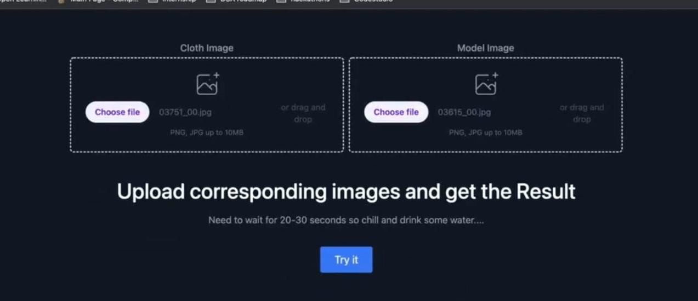

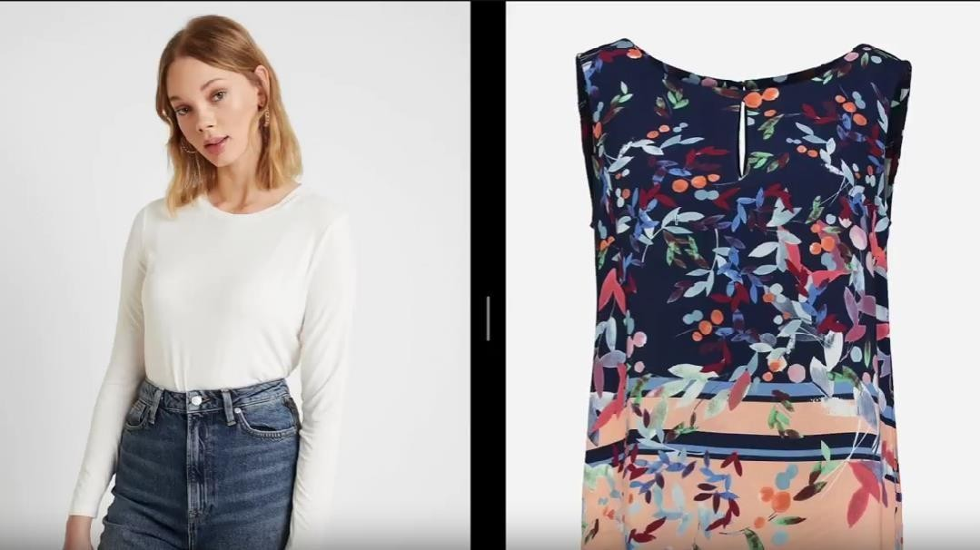

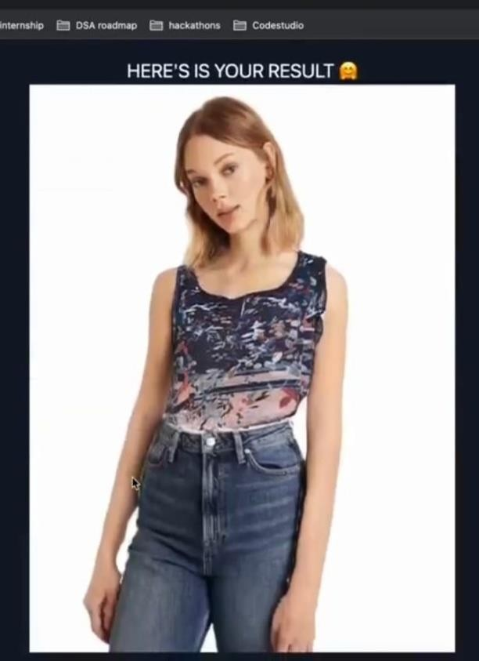

# 4. Resource & Environment Needs

## Test Environment

It mentions the minimum **hardware** requirements that will be used to test the Application. Following **software’s** are required in addition to client-specific software.

* Windows 8 and above
* Office 2013 and above
* MS Exchange, etc.

# 5. Terms/Acronyms

Make a mention of any terms or acronyms used in the project

|  |  |
| --- | --- |
| **TERM/ACRONYM** | **DEFINITION** |
| API | Application Program Interface |
| AUT | Application Under Test |